Exercise 10
1.Display the sum of ages of employees working at BIgnet.
SELECT SUM(age) FROM `employee_data`;
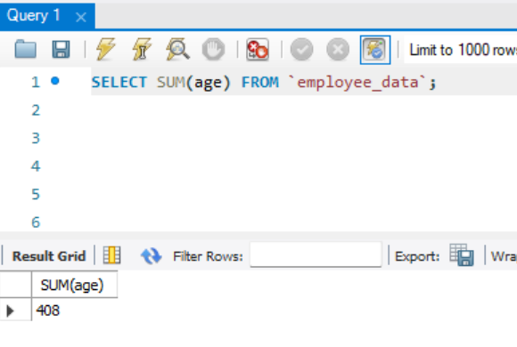
2. How would you calculate the total of years of service the employees of Bignet have in the company?
SELECT SUM(yos) FROM `employee_data`;
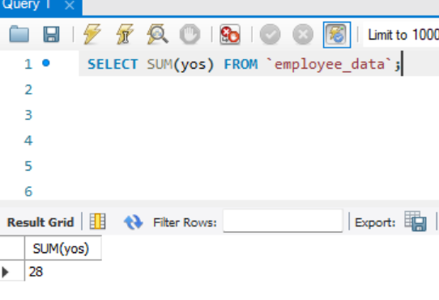
3. Calculatr the sum of salaries and the average age of employees who hold “Programmer” title.
SELECT SUM(salary), AVG(age) FROM `employee_data` WHERE title like "Programmer";
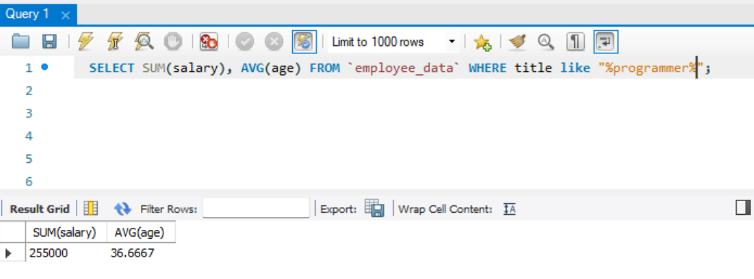
4. What do you understand from the following statement?
Select (SUM(perks) / Sum(salary) * 100) from employee_data;

It gives the total perks as a percentage of the total salary related to all employees.

